**6CI008 Database Design and Applications**

**2017/8 Semester One**

**Time Constrained Assessment (TCA)**

**The TCA is worth 40% of the overall Portfolio mark**

# Part One – 20% of TCA

You will be presented with 10 multiple choice questions on the day of the TCA, worth 2 marks each.

These will be based on the quizzes that are available under the Canvas topic.

Do note, the potential answers presented may not follow the same order as seen on Canvas, so ensure you understand the answers fully! There is no negative marking; a wrong answer achieves 0 marks.

# Part Two – 80% of TCA

You are the Project Manager of a team of database designers who work in Gold Coast’s IT Department who will produce a database application for *21st Commonwealth Games*. At the moment the department uses standard ER diagrams and normalisation techniques when designing any database systems. The Mayor of the Gold Coast has offered to invest in some tools to aid with database design and to consider using more advanced design techniques. The Mayor is also concerned about the security of the application.

Write a report for the Mayor that discusses:

1. The advantages and disadvantages of using advanced techniques such as the Enhanced Entity Relationship (EER) model compared to the traditional approach of using standard ER diagrams and normalisation.
2. Evaluates the Oracle Data Modeler and Designer tools.

This section should discuss the tools and how they aide the development of a database system. Discuss what advantages and disadvantages such tools have.

1. Reviews what database specific security issues could affect a database application.

This section should give an overview of what problems could affect a database and what steps can be taken to prevent them.

Include examples where appropriate, which should be based on the *Commonwealth Games* scenario as far as possible.

As examples to use in your discussion, consider the data models given in Appendix One and their mappings in Appendix Two. These represent an extension of the Student-Module examples seen in the lectures. These approaches attempt to capture more of the semantics of a system than a convention ER diagram and normalisation.

Also consider the points discussed in the following papers (available on Canvas):

* “*A Comparative Analysis of Entity-Relationship Diagrams” by* Song I., Evans M, and Park E. (1995), Journal of Computer and Software Engineering*,* 3(4): 427-459, as a framework for the comparisons. (Available from <http://www.cis.drexel.edu/faculty/song/publ.htm>).
* “Baloney Detection Kit” Barden, Dick, The Journal of Conceptual Modeling Issue Number 10, August 1999, reprinted at: [*http://www.inconcept.com/JCM/August1999/barden.html*](http://www.inconcept.com/JCM/August1999/barden.html)
* “*Making Data Models Readable, David Hay Information Systems Management,* 15(1), Winter 1998, pp 21-33, *reprinted at* [*http://www.essentialstrategies.com/publications/modeling/makingrd.htm*](http://www.essentialstrategies.com/publications/modeling/makingrd.htm)

For section 1, issues you may want to discuss include, but are not limited to:

* What additional features these approaches have.
* How might they address the need to capture more business rules?
* Readability of the models
* What support they have for concepts not found in the traditional approaches, such as weak-entities and inheritance.
* How readable the approaches are? Consider the potential users of these techniques (e.g., database designers, database programmers, end users, etc.).
* The quality of the mapping techniques used instead of normalisation.

Any examples should be based on the *Commonwealth Games* assessment if appropriate.

A higher mark will be awarded to students who show evidence of background reading in their reports. Full Harvard referencing is not expected under exam conditions however, instead some mention of the author(s) and year will be sufficient.

**TCA marks breakdown summary:**

* **Part 1 is worth 20% of the TCA**
* **Part 2 is worth 80% of the TCA**

# Appendix One – Conceptual Diagrams

## Oracle Data Modeller Tool

* 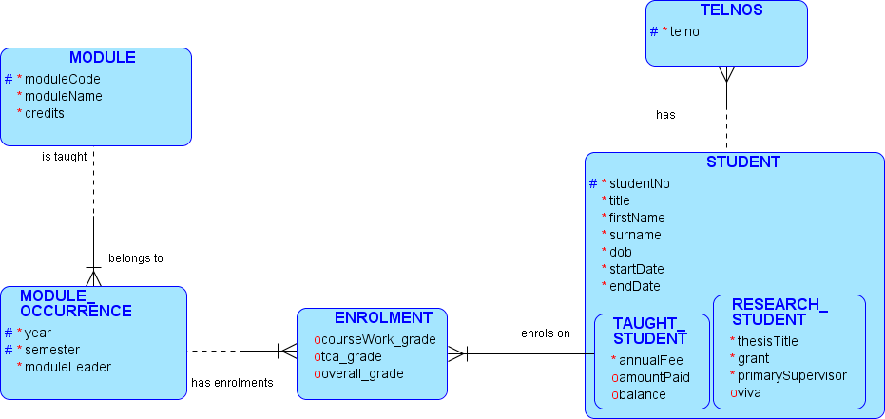

## Enhanced Entity Relationship Diagram (Elmasri & Navathe approach)

* 

# Appendix Two – Logical Mappings

For brevity, the comments generated by the Data Modeller tool have been removed.

For consistency both approaches use the single table approach for mapping the subtypes (Option B).

## Oracle Data Modeller Tool

CREATE TABLE Enrolment (

courseWork_grade NUMBER(3) CHECK ( courseWork_grade BETWEEN 0 AND 100) ,

tca_grade NUMBER(3) CHECK ( tca_grade BETWEEN 0 AND 100) ,

overall_grade NUMBER(3) CHECK ( overall_grade BETWEEN 0 AND 100 )) ,

year NUMBER (4) NOT NULL ,

semester VARCHAR2 (4) CHECK (semester IN (‘SEM1’,’SEM2’,’YEAR’,’SV’) NOT NULL,

moduleCode VARCHAR2 (6) NOT NULL ,

studentNo VARCHAR2 (7) NOT NULL):

ALTER TABLE Enrolment

ADD CONSTRAINT PK_Takes PRIMARY KEY (year, semester, moduleCode, studentNo );

CREATE TABLE Module (

moduleCode VARCHAR2 (6) NOT NULL ,

moduleName VARCHAR2 (30) NOT NULL ,

credits NUMBER (3) NOT NULL );

ALTER TABLE Module

ADD CONSTRAINT Module_PK PRIMARY KEY ( moduleCode ) ;

CREATE TABLE Module_Occurrence (

year NUMBER (4) NOT NULL ,

semester VARCHAR2 (5) NOT NULL ,

moduleLeader VARCHAR2 (20) NOT NULL ,

moduleCode VARCHAR2 (6) NOT NULL );

ALTER TABLE Module_Occurrence

ADD CONSTRAINT "Module Occurrence_PK" PRIMARY KEY ( year, semester, moduleCode ) ;

CREATE TABLE Student (

studentNo VARCHAR2 (7) NOT NULL ,

title VARCHAR2 (4) NOT NULL CHECK ( title IN ('Dr' , 'Miss' , 'Mr' , 'Mrs' , 'Ms' , 'Prof' , 'Rev' )) ,

firstName VARCHAR2 (20) NOT NULL ,

surname VARCHAR2 (20) NOT NULL ,

dob DATE NOT NULL ,

startDate DATE DEFAULT SYSDATE NOT NULL ,

endDate DATE NOT NULL ,

annualFee NUMBER (7,2) DEFAULT 9000 ,

amountPaid NUMBER (7,2) DEFAULT 0 ,

balance NUMBER (7,2) AS ( annualFee-amountPaid ) ,

thesisTitle VARCHAR2 (50) ,

grant NUMBER (7,2) ,

primarySupervisor VARCHAR2 (30) ,

viva DATE );

ALTER TABLE Student

ADD CONSTRAINT Student_PK PRIMARY KEY ( studentNo ) ;

CREATE TABLE TelNos (

telno VARCHAR2 (15) NOT NULL ,

studentNo VARCHAR2 (7) NOT NULL );

ALTER TABLE TelNos

ADD CONSTRAINT TelNos_PK PRIMARY KEY ( telno, studentNo ) ;

ALTER TABLE TelNos

ADD CONSTRAINT contactNos FOREIGN KEY ( studentNo ) REFERENCES Student ( studentNo );

ALTER TABLE Enrolment

ADD CONSTRAINT enrolments FOREIGN KEY (year, semester, moduleCode)

REFERENCES Module_Occurrence (year, semester, moduleCode);

ALTER TABLE Enrolment

ADD CONSTRAINT enrolsOn FOREIGN KEY ( studentNo ) REFERENCES Student( studentNo )

ON DELETE CASCADE;

ALTER TABLE Module_Occurrence

ADD CONSTRAINT taughtOn FOREIGN KEY (moduleCode) REFERENCES Module ( moduleCode);

## Enhanced Entity Relationship Diagram

Created using the steps shown in weeks 3 and 5:

Module(moduleCode, moduleName, credits)

ModuleOccurrence(moduleCode, year, semester, moduleLeader)

Student(studentno, title, firstname, surname, dob, startDate, endDate, annualFee, amountPaid, primarySupervisor, grant, researchTitle, viva)

Student_Telnos(studentNo, telno)

Enrolments(moduleCode, year, semester, studentNo, coursework_Grade, tca_grade, overall_grade)